- What is Java?
Ans:- Java technology is both a programming language and a platform from Oracle Corporation.

- Why Java is called as “Platform”?
ans:- A platform is basically the hardware or software environment in which a program runs. Java provides software-based platform i.e. JVM, which can run applications developed using the Java Programming Language.
- What are the features of Java ?
Ans:- Java has several powerful features that make it one of the most popular programming languages. Here are the key features:
1. Platform Independence
- Java follows the "Write Once, Run Anywhere" (WORA) principle.
- Java programs are compiled into bytecode, which can run on any system with a Java Virtual Machine (JVM).
2. Object-Oriented
- Java follows OOP principles like Encapsulation, Inheritance, Polymorphism, and Abstraction.
- Everything in Java is treated as an object.
3. Simple & Easy to Learn
- Java’s syntax is similar to C++ but removes complexities like pointers and multiple inheritance.
4. Secure
- Java uses a secure execution environment with features like:
  - Bytecode verification
  - No explicit memory management (no pointers)
  - Security Manager for access control
5. Robust (Strong & Reliable)
- Java has strong memory management (Garbage Collection).
- It provides exception handling to handle runtime errors.
6. Multi-threaded
- Java supports multithreading, allowing multiple tasks to execute concurrently.
7. High Performance
- Though Java is slower than C/C++, it uses Just-In-Time (JIT) Compilation to improve performance.
8. Distributed Computing
- Java supports Remote Method Invocation (RMI) and Enterprise Java Beans (EJB) for distributed applications.
9. Dynamic and Extensible
- Java can dynamically load new classes at runtime.
- It supports dynamic linking with external libraries.
10. Automatic Memory Management (Garbage Collection)
- Java has an automatic garbage collector to free memory occupied by unused objects.
11. Rich API and Large Standard Library
- Java provides a vast set of APIs for I/O operations, networking, utilities, database access (JDBC), XML parsing, etc.
12. Strong Community Support
- Java has huge community support, with frequent updates, frameworks, and tools.

- How java is platform independent ?
Ans:- Java program, once compiled , can be run on any platform without recompiling.

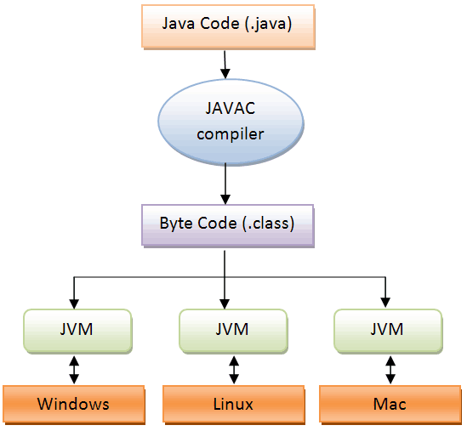

5) What does JDK contain?
Ans:-
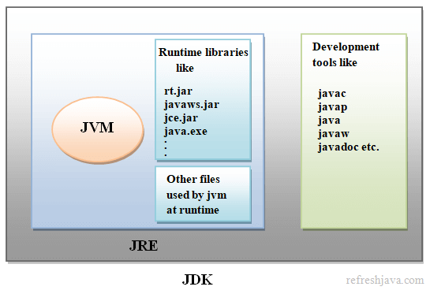

6) What is JVM ? What it does?
Ans:- A Java virtual machine (JVM), an implementation of the Java Virtual Machine Specification, interprets compiled Java binary code (called bytecode) for a computer's processor (or "hardware platform") so that it can perform a Java program's instructions. Java was designed to allow application programs to be built that could be run on any platform without having to be rewritten or recompiled by the programmer for each separate platform.
JVMs are available for various platforms (i.e.JVM is platform dependent).

It is:
- A specification where working of Java Virtual Machine is specified. But implementation provider is independent to choose the algorithm. Its implementation has been provided by Sun and other companies.
- An implementation Its implementation is different for different platforms.
- Runtime Instance Whenever you write java command on the command prompt to run the java class, an instance of JVM is created.

The JVM performs following operation:
- Loads code
- Verifies code
- Executes code

7) Why JVM is called as “virtual machine”?
Ans:- The JVM is "virtual" because it is generally implemented in software on top of a "real" hardware platform and operating system. All Java programs are compiled for the JVM. Therefore, the JVM must be implemented on a particular platform before compiled Java programs will run on that platform.

8)What is the lifetime of Java Virtual Machine ?
Ans:- When a Java application starts, a runtime instance of JVM is born. When the application completes, the instance dies.

9)Is JRE different for different Platforms ?
Ans:- yes

10)Difference bet’n C++ and java in terms of object creation.
Ans:- in C++ object can be created on stack as well as on heap (because java has given importance to late binding from the very beginning)

11)What is automatic garbage collection ?
Ans:- Automatic garbage collection is the process of looking at heap memory, identifying which objects are in use and which are not, and deleting the unused objects. An in use object, or a referenced object, means that some part of your program still maintains a pointer to that object. An unused object, or unreferenced object, is no longer referenced by any part of your program. So the memory used by an unreferenced object can be reclaimed.

12)Can we force garbage collection programmatically?
Ans:- no, we can at the most request for Garbage Collection using “System.gc()” or “Runtime.gc()”.

  - What is the signature of main function in java ?
Ans:- public static void main(String args[]) or public static void main(String …args)

14)Who invokes main() function ?
Ans:- JVM invokes main() function.

  - Explain java data types.
Ans:
Primitives

Data Type Size Description
byte 1 byte Stores whole numbers from -128 to 127

short 2 bytes Stores whole numbers from -32,768 to 32,767

int 4 bytes Stores whole numbers from -2,147,483,648 to 2,147,483,647

long 8 bytes Stores whole numbers from -9,223,372,036,854,775,808 to 9,223,372,036,854,775,807

float 4 bytes Stores fractional numbers. Range 1.40239846e-45f to 3.40282347e+38f

double 8 bytes Stores fractional number
Range
4.94065645841246544e-324 to 1.79769313486231570e+308s.

boolean 1 bit Stores true or false values
char 2 bytes Stores a single character/letter or ASCII values
range - 0 to 65535

Reference Types:
Classes and interfaces

  - How many types of comments are allowed in Java?
Ans:
in java we have 3 types of comments

a) single line
//

b) multiline

/* */

c) document comment ( in order to create documentation )

/** **/

  - What is unicode character in java
ans:
Unicode is a universal character encoding standard that represents almost all characters from different languages and symbols worldwide. In Java, characters are stored using Unicode (UTF-16 encoding).
Key Points:
- Java uses char data type to store Unicode characters.
- Each char in Java takes 2 bytes (16 bits) to support Unicode characters.
- Unicode characters are written as \uXXXX, where XXXX is a hexadecimal code.

  - What is object oriented programming
Ans:
Object-Oriented Programming (OOP) is a programming paradigm based on the concept of objects that contain data (attributes) and behavior (methods).

  - What is class and object ? What are their real life examples?
Ans:
Class is just a blueprint , an idea based on which object/s can be constructed. An object is an instance of a class. It has a state (values of attributes) and behavior (methods of the class).

Real-Life Examples of Class and Object
Real-World Entity | Class (Template) | Object (Instance)
Car | Car class | Toyota, BMW, Honda
Mobile Phone | Phone class | iPhone 14, Samsung Galaxy S23
Human | Person class | John, Alice, Ravi
Bank Account | BankAccount class | Savings account, Checking account

